

Usama Iftikhar Butt

Gulfam Sidhu

Nabeel Ahsan

Muhammad Ahmad

Final Project Global terrorism analysis

Course Data Mining

Submitted: 22-Dec-19

**Terrorist attacks around the world:**

According to a survey, about 218 million people are affected by calamities, natural and man-made, per annum and about 68000 people lose their lives every year. The frequency of natural disasters like earthquakes, volcanoes etc. have remained broadly constant, but the number of terrorist activities have grown over the period.

The aim of this project is to explore the terrorist events around the world. Interactive Plots are used in this project for making the exploration easy and more informative.

**About Dataset:**

Dataset is about all terrorist attacks between 1970 to 2012. There are over one hundred thousand rows.

**Columns:**

There are about 100+ columns in dataset. But the most important columns we are using are:

* Year, Month & Day
* Country, Region & City
* Latitude & longitude
* Attack type
* Target
* Killed
* Wounded
* Weapon type

**Problem Statement:**

“Visualization of Data to Find Pattern of Terror Which Country is Facing Deaths, Which Places are Target Most, When and Why Terrorism is Active?”

**Explanation:**

We have visualized data in different ways to extract important information from the dataset. We have drawn graphs for countries, region & cities having highest attacks over time. We have drawn graphs for the most weapons used in attacks. And also drawn graphs for the most targets of terrorists.

**Some extracted analysis from data:**

These are some of the analysis of terrorism globally.

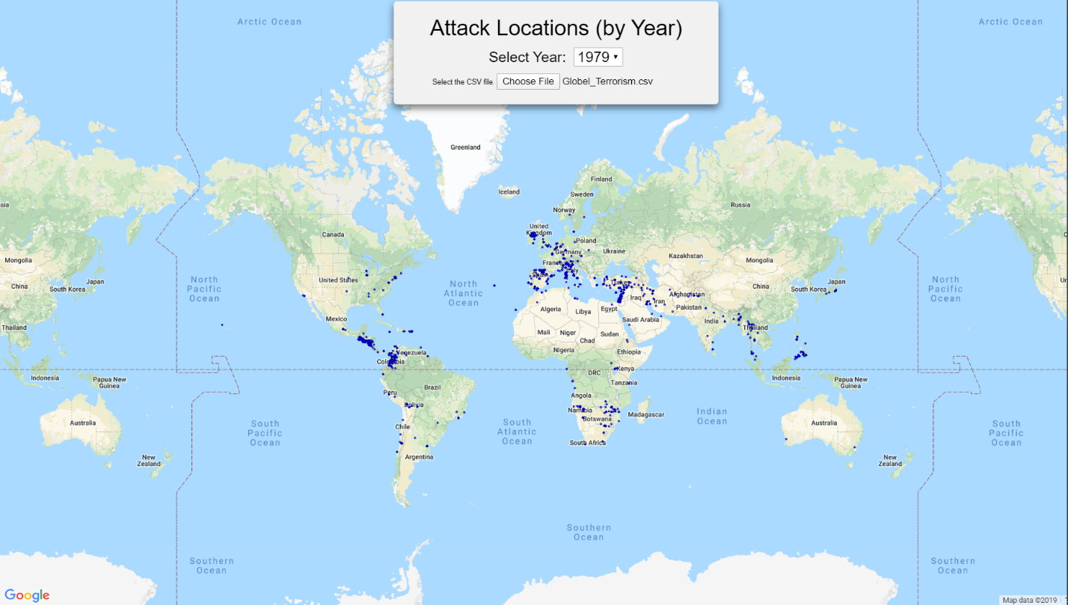**Attacks over the world in 1979:**

**Basic analysis:**

Iraq is the country having highest number of attacks. And the maximum number of people killed in one attack is 1384 occurred in United States.

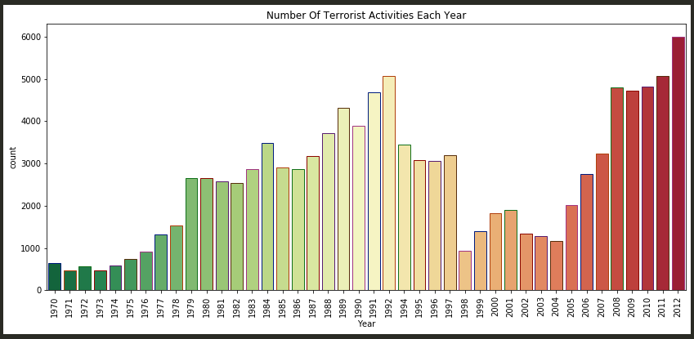**Number of attacks per year:**

**Attacking method by terrorists:**

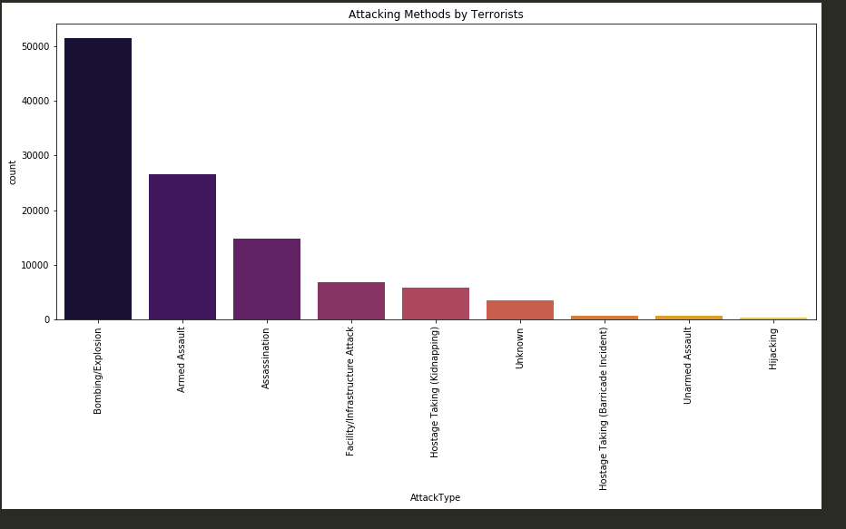

**Targets of terrorists:**

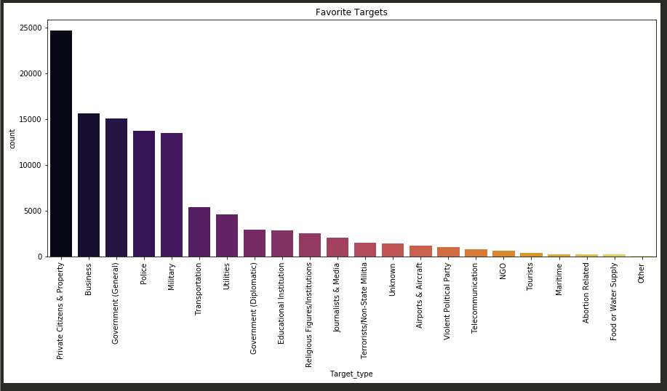

**Trends in Terrorism:**

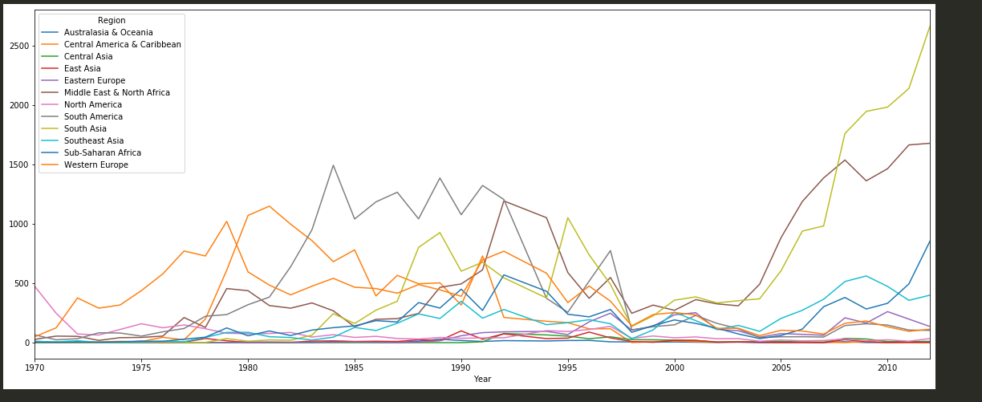

**Attack types vs Region:**

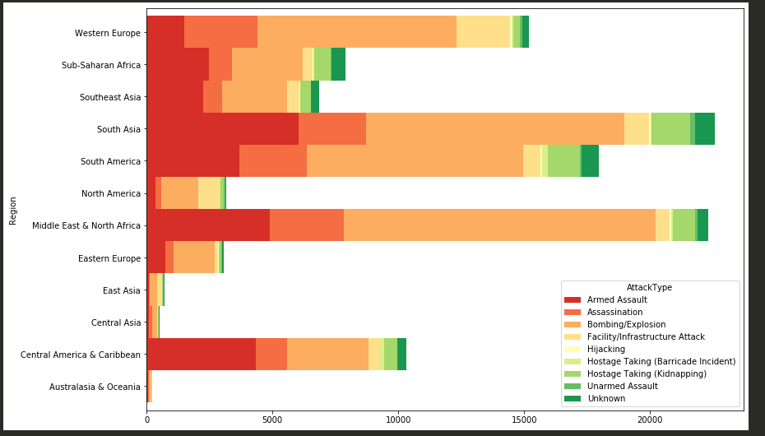

**No. of attacks vs killed:**

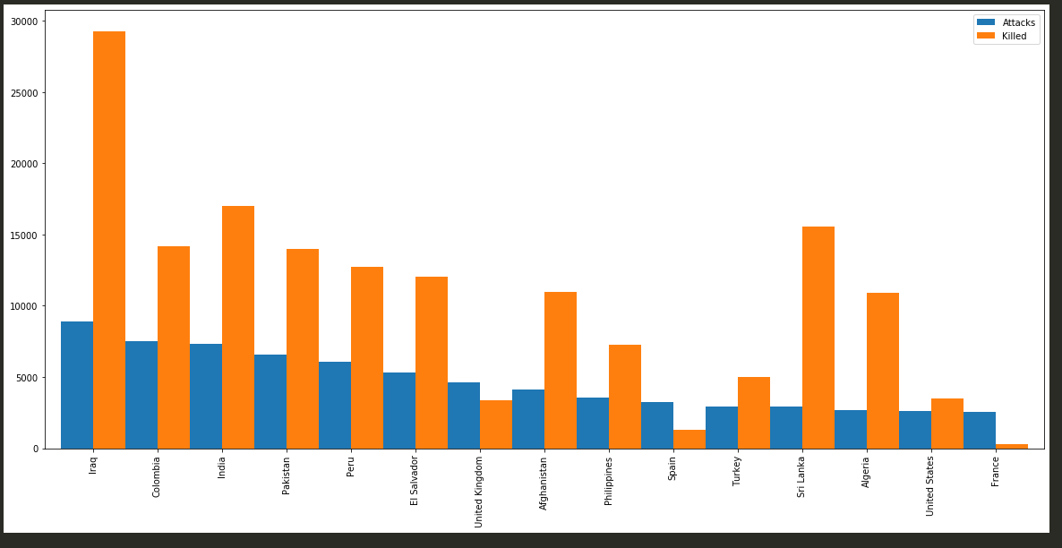

**Terrorism in Pakistan:**

Now there is some analysis for Pakistan.

**Trend in number of attacks:**

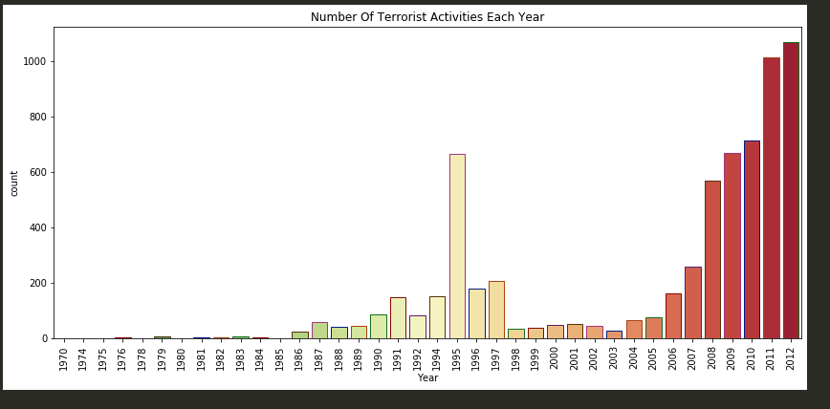

**Attacks vs Killed:**

